**Chapter 3. Lab Assignment (20 points)**

**Name: _______**

**Task 1**. Based the following images. Explain the process of encapsulation and de-encapsulation when a application message is sent to the server [www.google.com](http://www.google.com). **Detail** each step in the 5-layer architecture (suppose your host is in the Ethernet subnetwork, and the google server is in the PPP subnetwork)(**10 points**).

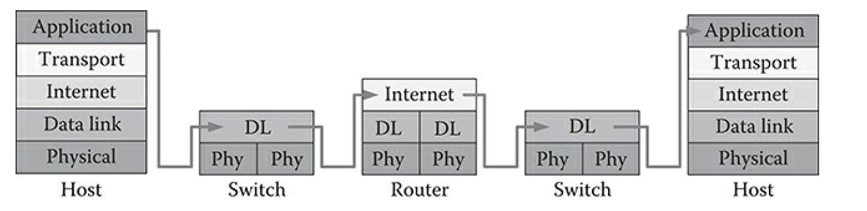

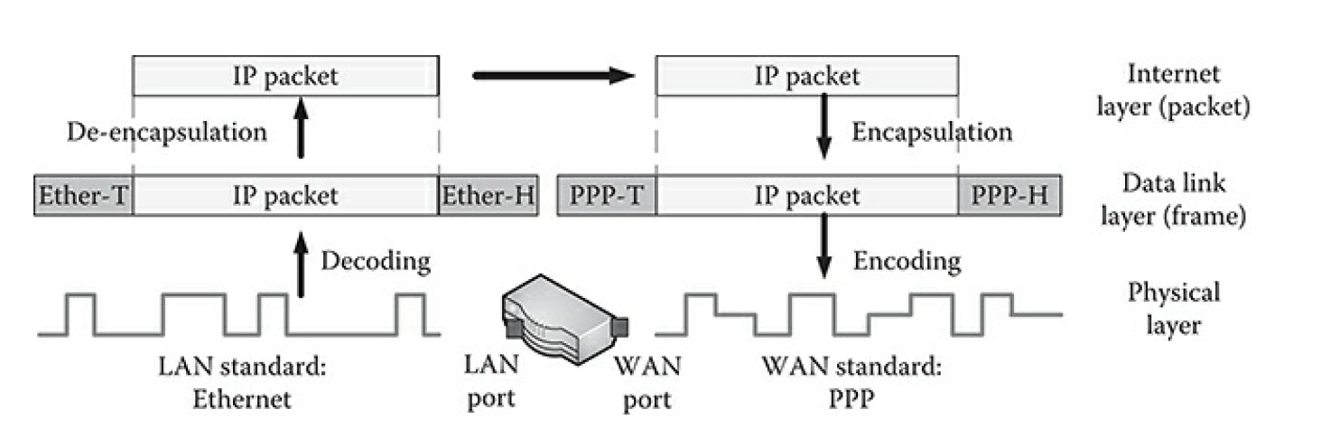

**Task 2**. Compare regular a switch and a router. List 2 common features/functions and 5 different features/functions between them (**5 points**)

**Task 3.** Identify how many collision domains are there in the following networks (**5 points**)

Figure 1 (top-left)

2

Figure 2 (top-right)

5

Figure 3 (bottom-left)

2

Figure 4 (bottom-right)

6

